Protocol for testing noise levels in Plexon recording systems

March 9, 2014

See also: <http://www.ncbi.nlm.nih.gov/pubmed/25559004>

There are multiple sources of “noise” that can enter our recordings. This protocol describes how to setup a recording in a dish of saline to quantify the amplitude and frequency content of this noise in the absence of any additional sources of variance from neurons and mice. Checking this before and after changes to the system can quantify whether the changes affected recording quality.

* Turn the Plexon system on and start streaming data. Mount an array on the end of the headstage, and position the tips of the wires in a dish of saline using putty to hold it. Make sure the ground wire is also in the saline.

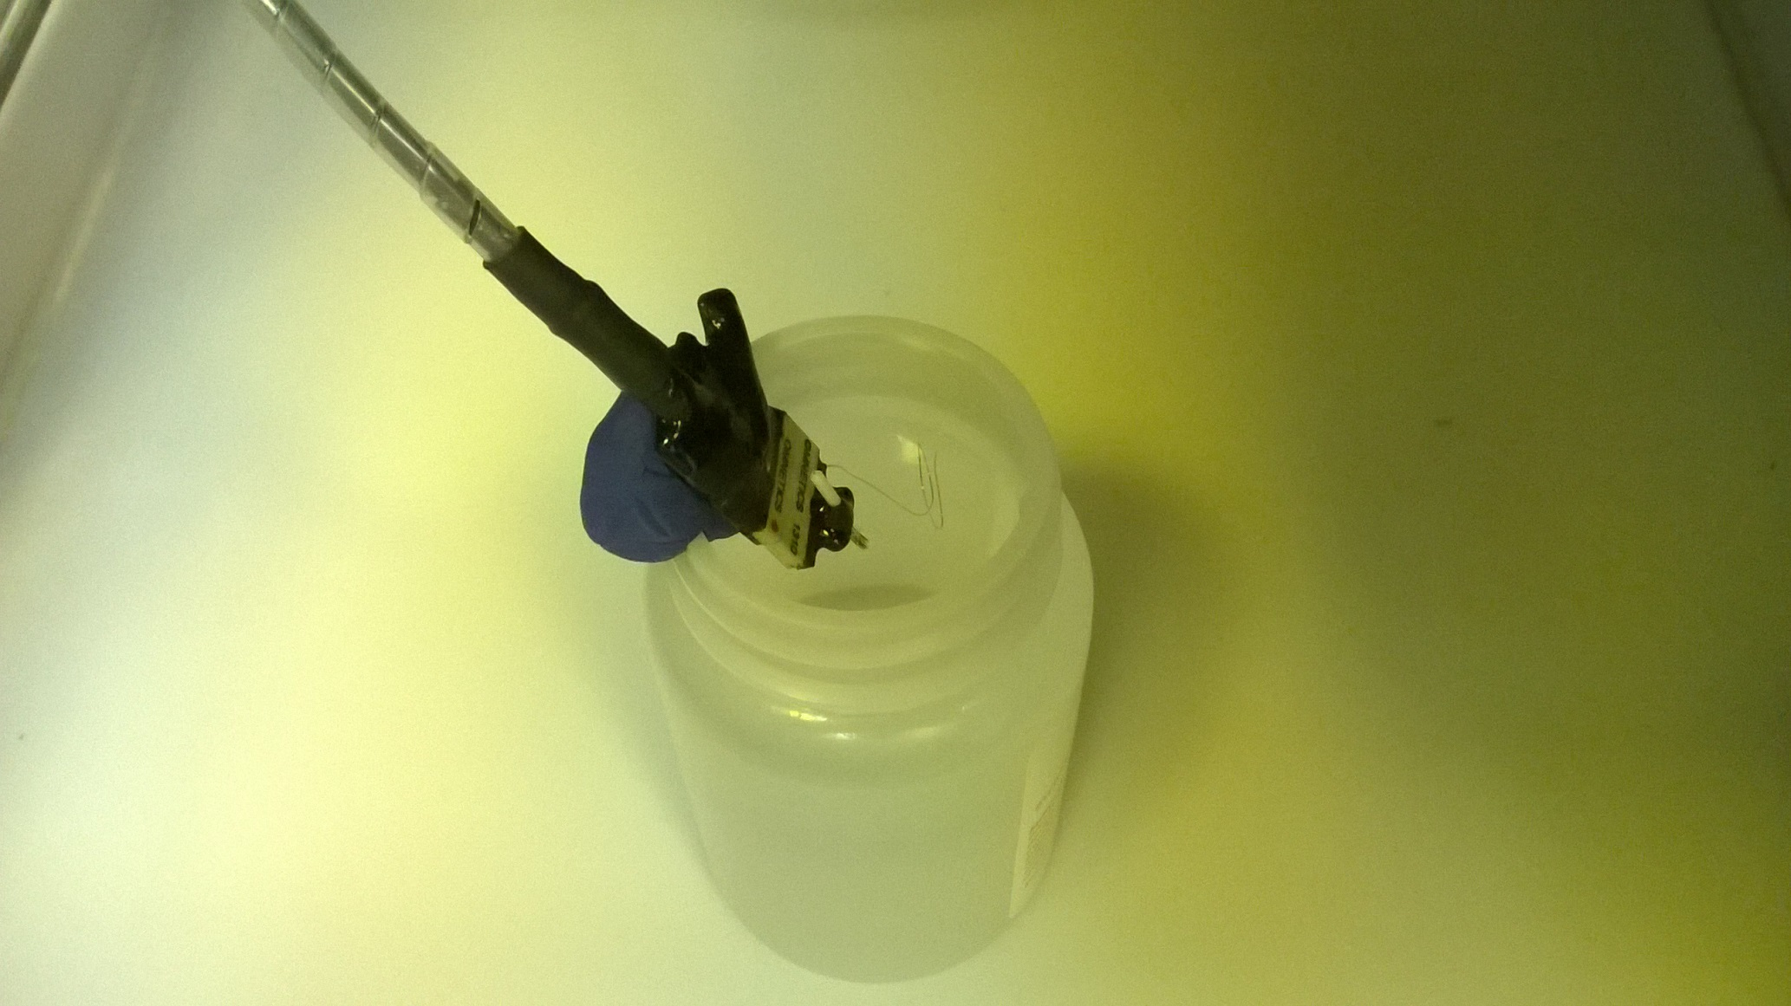

* In the “properties spreadsheet” tab, set the gain of each channel to 4000, the threshold to -5, and turn on wideband recording.

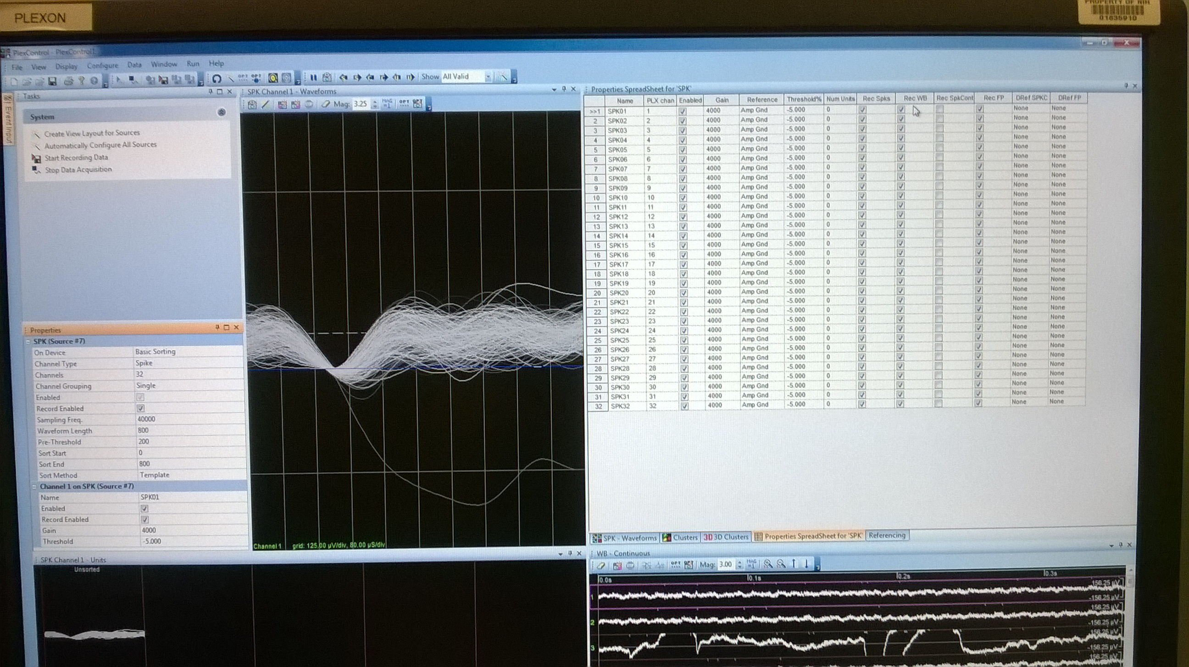

* Record wideband data from all channels for ~1 minute.
* Open the files in Neuroexplorer and use the 1D data viewer to visualize the wideband channels to see the amplitude of the noise band. This will also tell you if any channels in the recording system are particularly bad or might be damaged.
* To quantify this, copy the continuous wideband data into Excel and calculate the Root Mean Squared of the data.
* Use spectral analysis to see if there are any peaks at specific frequencies in the data:

